A Report on Welfare Program held on 10th September 2022 at Shubhakshika

On the 10th day of September 2022, Shubhakshika organized a child welfare program at its Amar Jyoti Colony, Rohini Sector-16 campus to give a detailed knowledge to its beneficiaries about child rights, care, protection, health and safety (unlawful sexual practices.
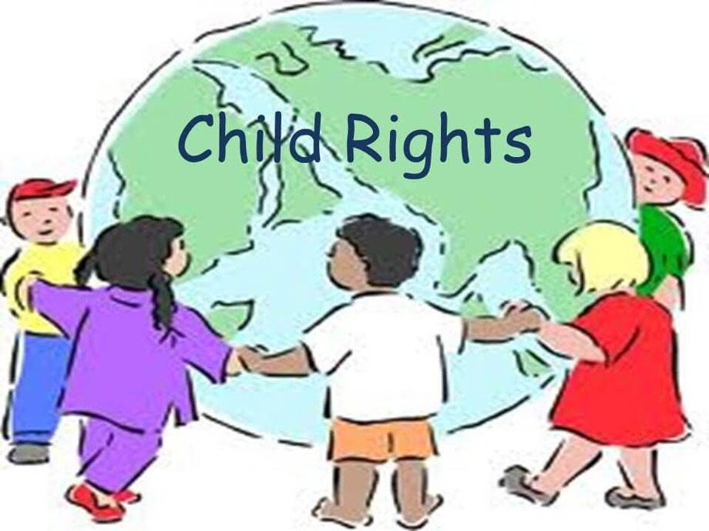
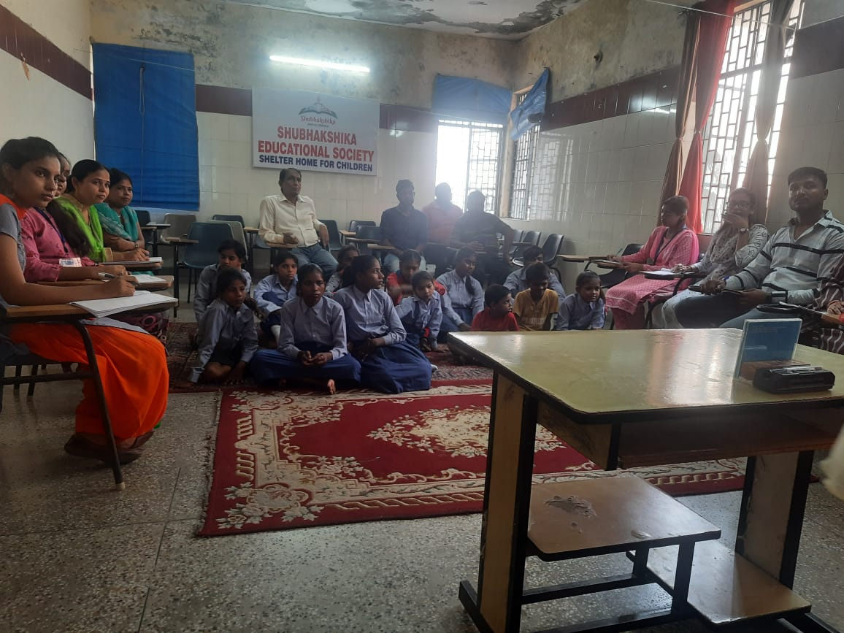
The chairperson and the founder of Shubhakshika Mrs. Usha Bhatnagar started the event by welcoming the key speaker, guests, members, staff and children. Mrs. Rita Darira, ex- member CWC and Maintenance Tribunal, Govt. of NCTD was the key speaker for the event. She started with the introduction and described about the minor child (below 18 years of age) United Nation Organization and its contributions towards child rights, and safety. The commission on sustainable development was created on 1st December 1992 to ensure the effective follow up at national and international levels. The government of India had decided on the 11th of December,1992 to the convention on the child rights.
The NPCHR was created at national level through Ministry of women and child development which has prescribed a set of standards to be adhered to by all state parties (like DPCHR in securing the best interest of the child. Child rights include the following;
1. Right to food
2. Right to education
3. Right to basic amenities
4. Right to health
5. Right to protection

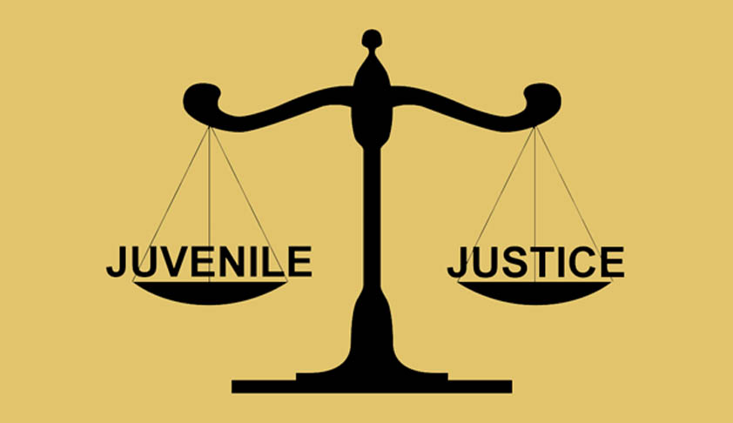
In the year 1998 Plan International motivated people to work for children. They started their work in India after motivating people to work for social concepts she added. Juvenile and Justice Act 2000 to consolidate and amend the law in conflict with law (by creating JJB) and children in need of care and protection (by CWC), by providing for proper care, protection and treatment by catering to their development needs and by adopting a child friendly approach.
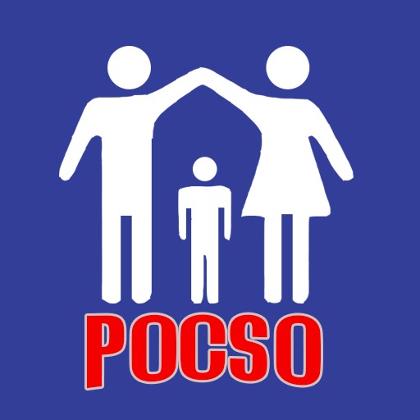
Further she discussed that according to a study of National crime bureau, 90% girl child gets abused at home and workplace. Child abuse was added in Juvenile and Justice Act in 2007. Another amendment took place in 2009 with CHUPPI TODO CAMPAIGN (CD) after a slum mobilization and research of Plan India.
With the intent to effectively address the evil of sexual exploitation and sexual abuse of children, Protection of Children from Sexual Offences Act POCSO was passed by the parliament in the year 2012 and enforced on Children’s day, 14th November 2012 all across the nation. The following details were necessary to put on;
1. Blood group 2. Personal detail 3. Medical reference 4. Family status
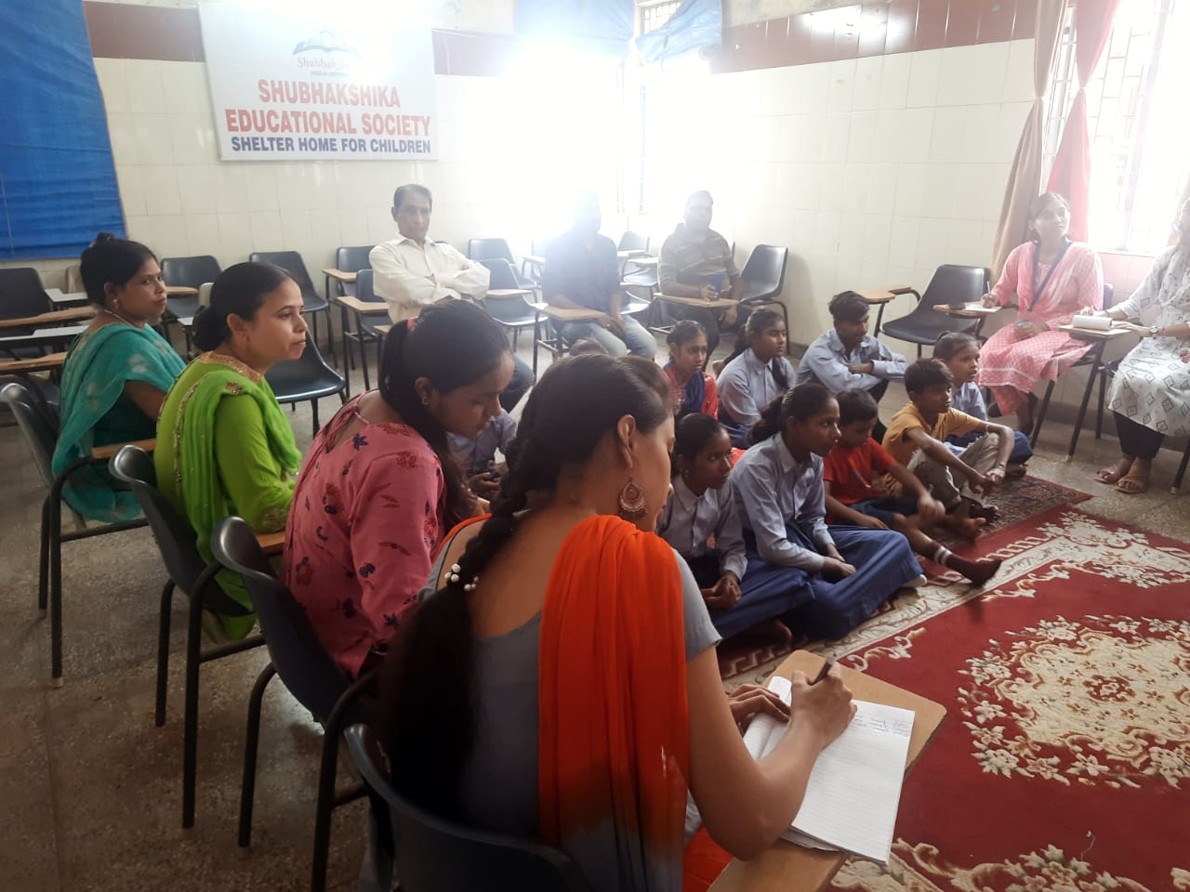
According to the survey of 2013 by National Crime Bureau there are 50 % of girls who are assaulted at their home and 35% of them are assaulted by father or elder brother drunken and abused cases were found. During the discussion of POCSO, she told us about the highlight case of 2013 –2014 a girl of 6 years who was sexually abused by her close blood relation hiding his personal identity and become accused after 3 to 4 years of investigation.
Role of NGO a special Nirbhaya case fund provided by POCSO court for the welfare of the victim was created by the ministry of law throughout India. In the case of Nirbhaya fund, Non-government organization help to open bank account or fixed deposit of victim. After a long discussion she cleared case properly, a girl who was sexual abused by anyone the cloths of victim, things like shoes to hair sample at the time of incident (case property) and are handed over to the investigating officer for DNA and medical tests.
Finally, she told us about MLC (Medical legal document) whenever we see a stain on victim. CWC will approve a support of that case. We provide an emergency test whenever we see a sign of stain or unlawful sexual activity with the child with NGO support person. A support person is a person with whom the victim is comfortable with. The speaker also interacted with beneficiaries and audience, there were a lot of questions from audience and she cleared all the doubts and queries.
She concluded by saying that the children are rising that the children are blooming flowers, rising stars and lamps in our temple and they need love, care and affection. They are the future of our country.
The event successfully held with the closing remarks and vote of thanks by the chairperson.

